Output of SQL Queries:

* Output of All Tables (Customers, Product, Transactions)

1. Customers table

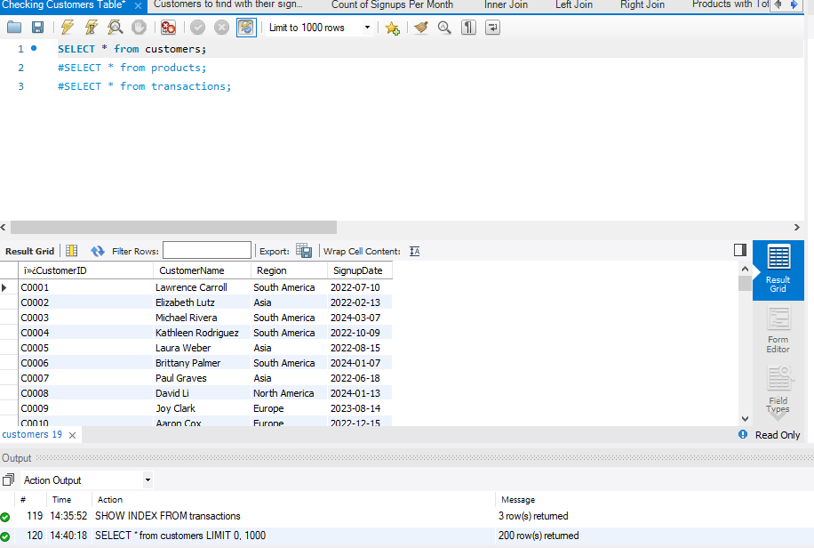

1. Product table

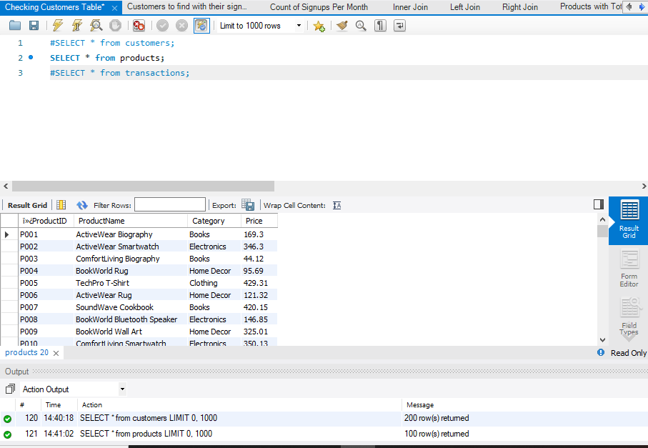

3.

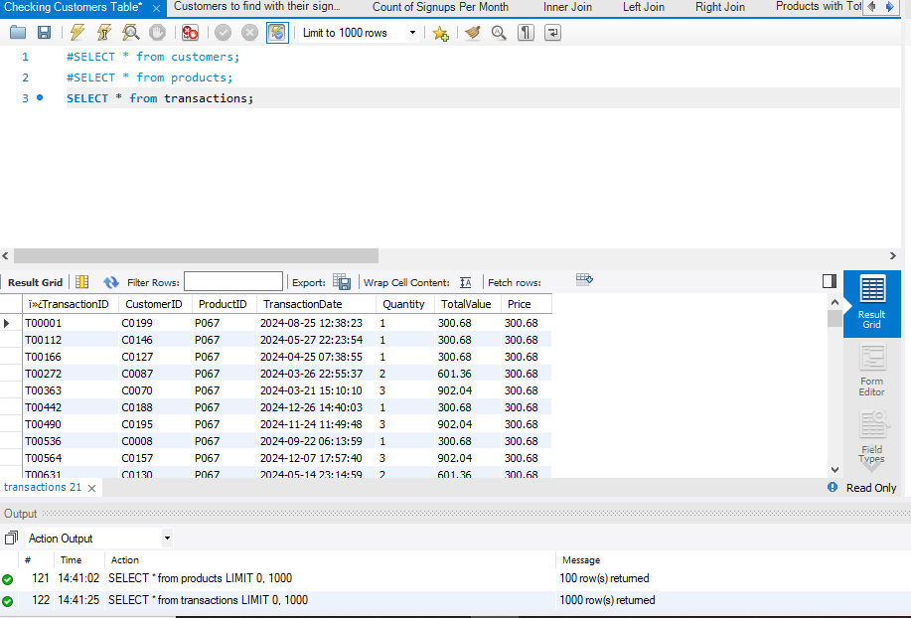

* Use SELECT, WHERE, ORDER BY, GROUP BY

Customers to find with their signupdate

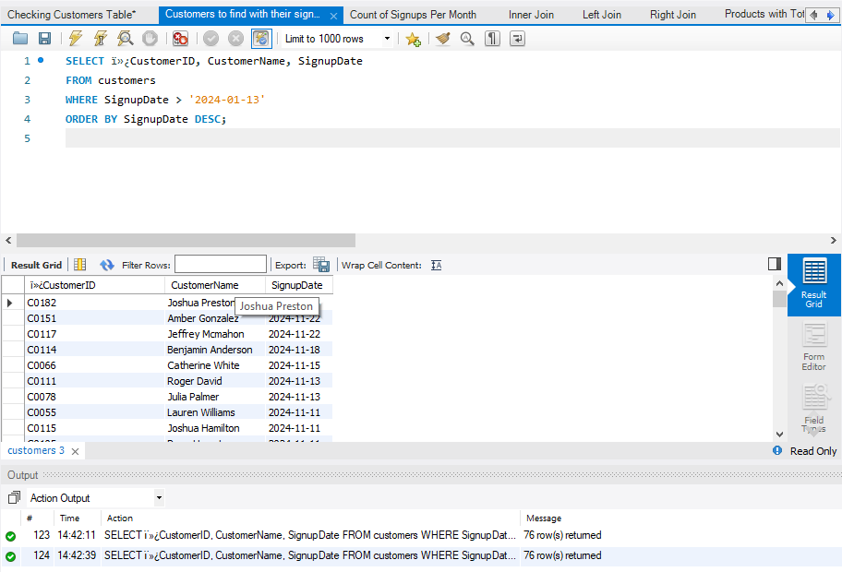

Count of signups per month

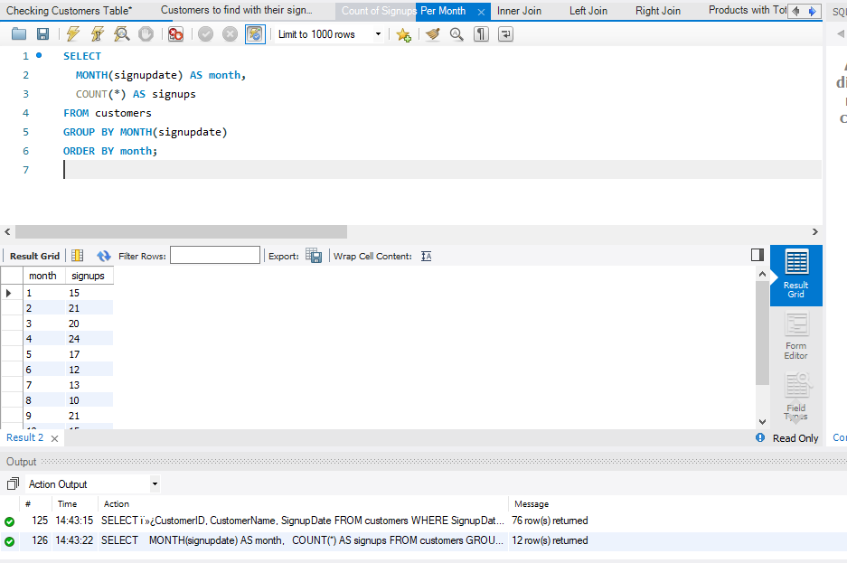

* Use JOINS (INNER, LEFT, RIGHT)

Inner Join

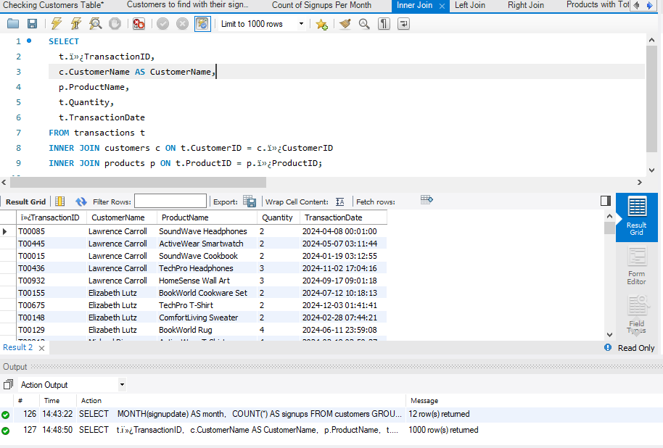

Left Join

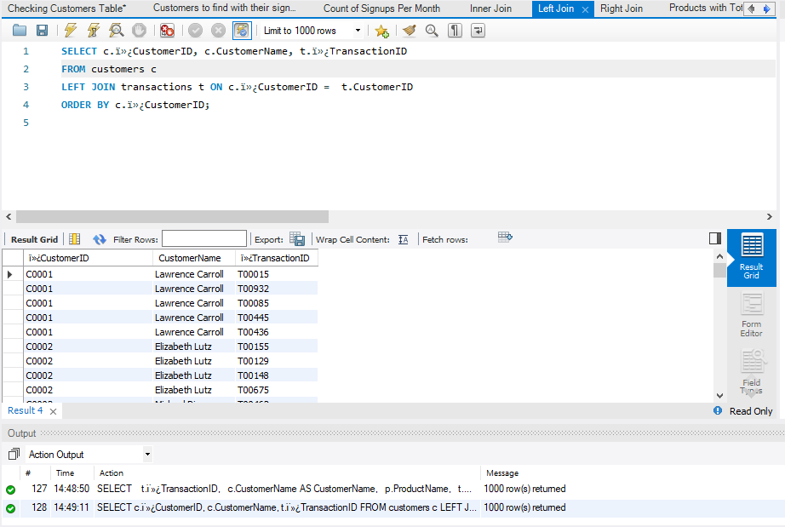

Right Join

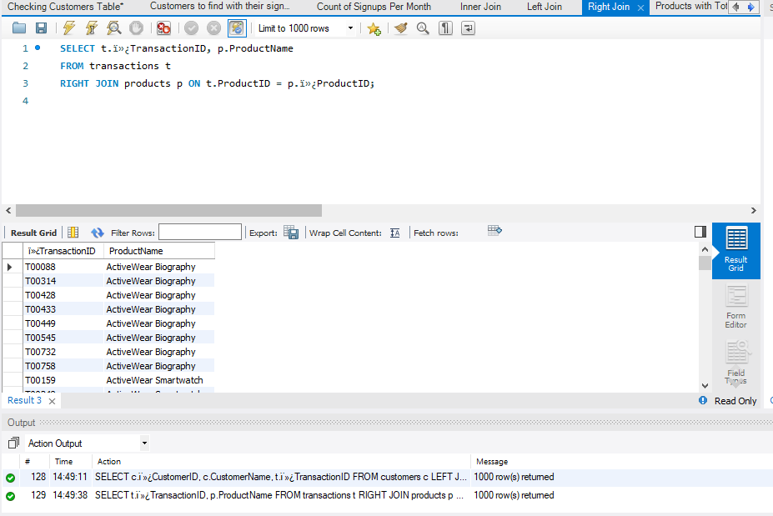

* Write subqueries

Products with Total Sales Higher Than Average

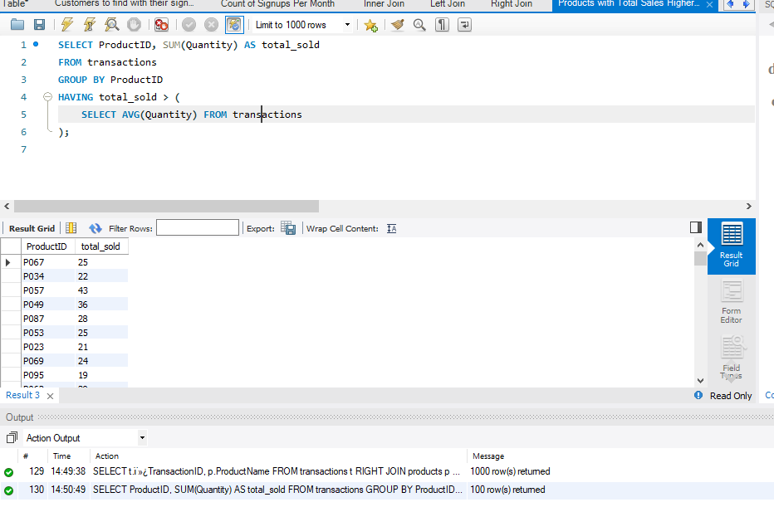

* Aggregate Functions

1. Sum Function

# Total Revenue per product

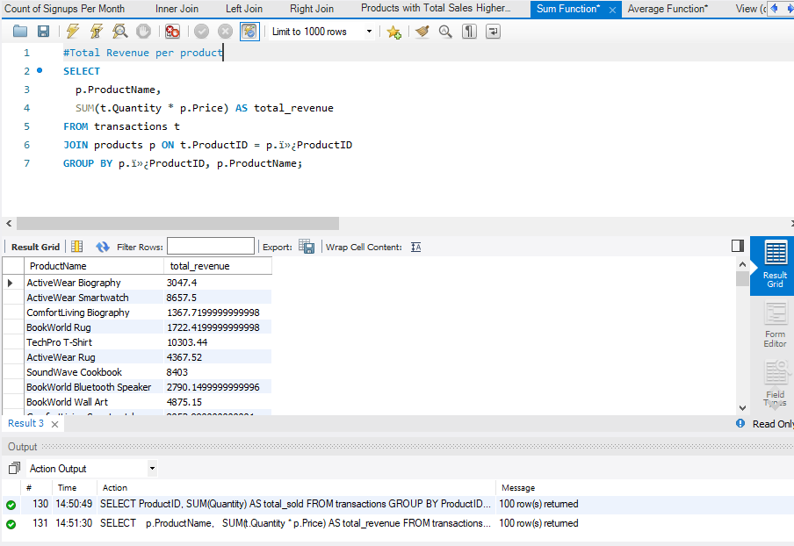

1. Average Function

#Average spend per customer

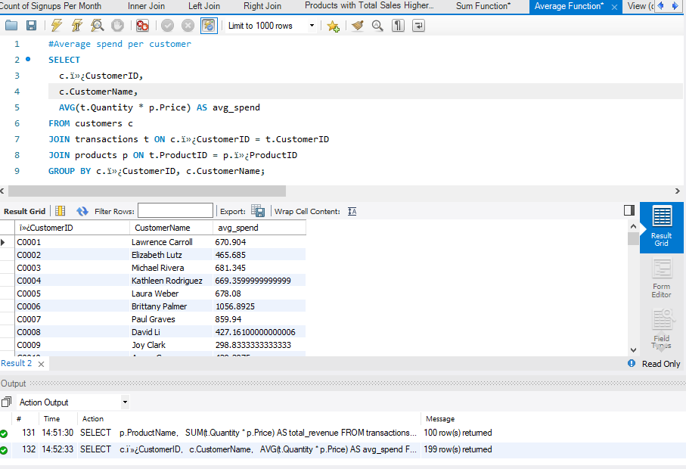

* View

# View for customer purchase

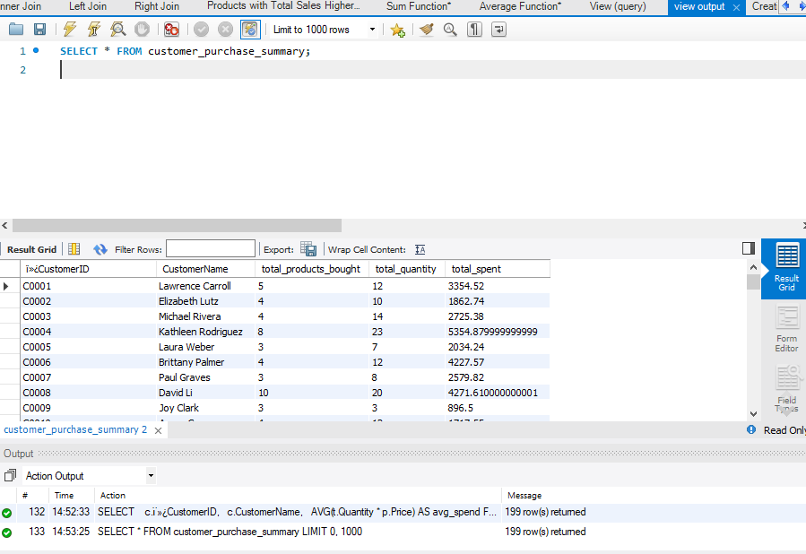

* Indexes

